Press release ifm-pm 875/0926 Area: Company news

ifm international exchange programme: young people cross borders and build connections
Essen, 9 September 2026. This summer, the ifm group of companies launched a special international exchange programme: children and young people from ifm employee families around the world visited one another, travelling to Germany, France, the United Kingdom, China and the United States.
At first glance, an exchange programme organised through a parent’s employer may seem unusual to many teenagers. However, over the summer months, a number of young members of the ‘ifmily’, as ifm refers to its team and their families, took advantage of this unique opportunity. ‘Bridges between cultures are built when people truly meet and connect with one another,’ says Osmir Ribeiro, CSO Subsidiaries at ifm. ‘The aim is to give young people the opportunity to understand differences, discover common ground and build friendships that transcend national borders.’ To achieve this, ifm developed a varied and engaging programme. At the beginning of August, international participants from around the world spent one and a half weeks with host families in Essen and the surrounding area, home to the company’s headquarters. The initiative was organised in cooperation with AFS Intercultural Programs. During their stay, the young participants not only enjoyed a range of excursions but also visited the ifm logistics centre and took part in a joint treasure hunt across the city of Essen. Following their stay in Germany, the German participants travelled with their exchange partners to their home countries, spending nine days in Europe, Asia and the Americas.
A wealth of international experience
It went down well – both with the participants and with the staff who hosted the visiting young people. ‘Through this exchange programme, children from different countries and cultures have formed meaningful friendships and gained valuable international experience,’ says Chunhua Chen, an ifm employee based in Shanghai, China. The 17-year-old American participant, Jude Novak, is delighted with his new experiences: ‘The programme has not only deepened my understanding of American culture, but also that of European culture. The exchange was truly a life-changing experience.’
The programme is being further developed
Even after the exchange programme, the families stay in touch. The aim is to build long-term links between the various ifm sites around the world. The project is now set to be further developed so that, over the next few years, a new generation will have the opportunity to break down barriers.

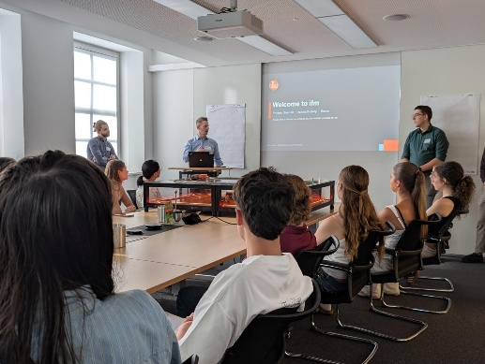 | ifm-pm 875 print.jpg  Young people from all over the world took part in the ifm exchange programme over the summer.

About the ifm group of companies
From a passion, to an idea, to success. Since its foundation in 1969, ifm has developed, produced and sold sensors, controllers, software and systems for industrial automation and for SAP-based solutions for supply chain management and shop floor integration worldwide. As one of the pioneers of Industry 4.0, ifm develops and implements consistent solutions to digitalise the entire value chain “from sensor to ERP”. Today, the second-generation family-run ifm group has more than 9,120 employees, including more than 5,260 in Germany, and is one of the worldwide market leaders. The group combines the internationality and innovative strength of a growing group of companies with the flexibility and close customer contact of a medium-sized company.

Printing free of charge – reference copy requested.

Editorial enquiries  Agentur Dr. Lantzsch  Jörg Lantzsch  Müllerstr. 5  65183 Wiesbaden  www.drlantzsch.de  Tel.: +49 611 205 93 71  Email: info@drlantzsch.de | Contact  ifm electronic gmbh  Simone Felderhoff  Friedrichstr. 1  45128 Essen  www.ifm.com  Tel.: +49 201 24 22 0  Fax: +49 201 24 22 1200  Email: presse@ifm.com

